Marking May 24th - the Day of the Holy Brothers Cyril and Methodius,
the Bulgarian Alphabet, Education and Culture
and Slavic Literature

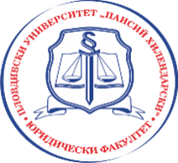
The Law Faculty at the University of Plovdiv Paisii Hilendarski
hereby invites you to the scientific workshop
with international participation

Issues on Medical Law

Subtopics & approximate time:
9:30 a.m. - 12:30 p.m. Informed Consent of the Patient
2:00 p.m. – 4:30 p.m. Assisted Reproduction

The workshop will take place on May 23 (Tuesday) at 9:30 a.m. in the University Rectorate – Compass Hall
Plovdiv, Bulgaria, March 2023

Looking forward to seeing you in Plovdiv!
You may participate in the event and present a report submitting a registration form by e-mail to Antonia Ilieva, PhD <a_ilieva@uni-plovdiv.bg> not later than April 19, 2023.

Organising Committee
Prof. Darina Zinovieva, PhD; Assoc. Prof. Angel Shopov, PhD; Ch. Assistant Prof. Antonia Ilieva, PhD

